SHARING AN ATTEMPT TO INTRODUCE SOIL REGENERATION TECHNIQUES INTO THE AGRO ECOLOGICAL PROGRAM FOR INCREASING PRODUCTIVITY, FOOD SECURITY, AND NUTRITION." RESULTAT FOR TWO YEARS EXPERIENCES BY PELUM DRC AND IT’S MEMBERS ORGANIZATIONS (O.M) .by Mr. NDIVITO MAKIMA Fidele : Country Coordinator.
PELUM DRC, through its member organizations, has launched a transition to agroecological agriculture or sustainable, resilient, and regenerative agriculture in response to soil degradation and climate change.
In its program to support participatory sustainable land and natural resource management, the food and nutritional insecurity of the populations of the eastern provinces of the Democratic Republic of Congo (North Kivu, South Kivu, Ituri, Haut Uélé, Tshopo, Haut Katanga, Tanganyika, and Maniema), which were once considered the country's breadbaskets but are now experiencing very high rates of food insecurity. food insecurity and malnutrition. Apart from the recurring wars and conflicts which are sources of population instability with the continuous displacement of small farmers and breeders who are sometimes in internally displaced persons camps and sometimes returning to their respective environments. They also face phenomena of soil degradation here
Deforestation
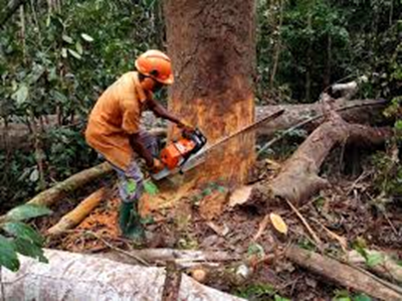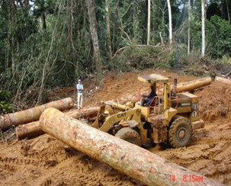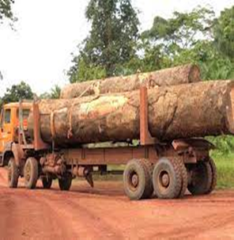
Bush fires
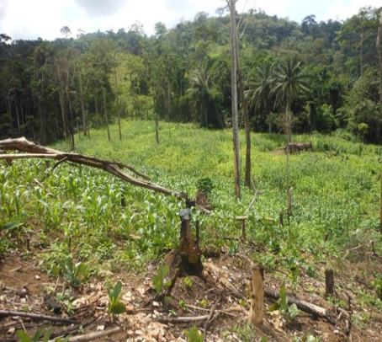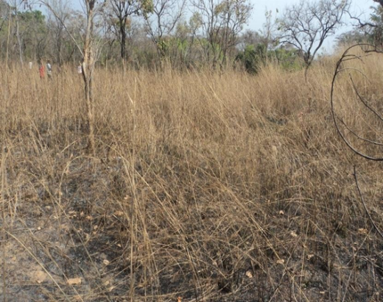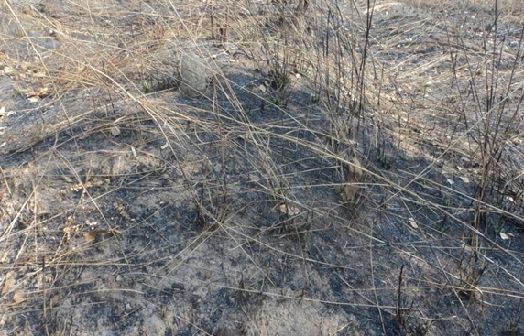
Cutting wood for cooking embers
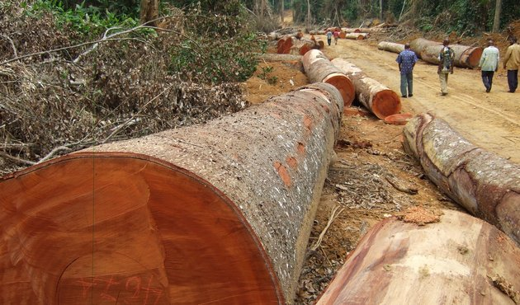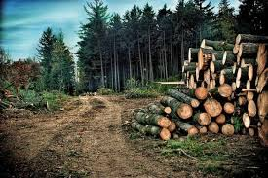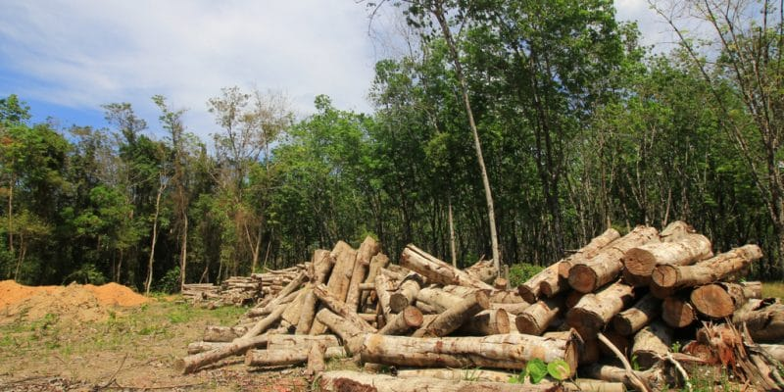
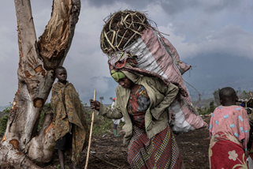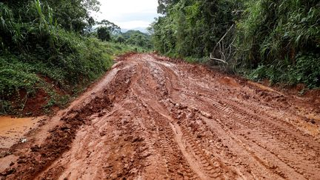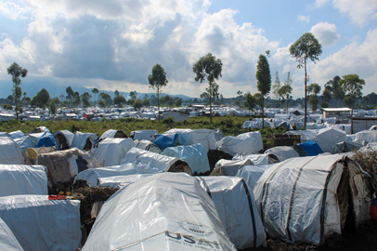
These destructions of natural resources are the cause of some of the following constraints:Erosion des sols
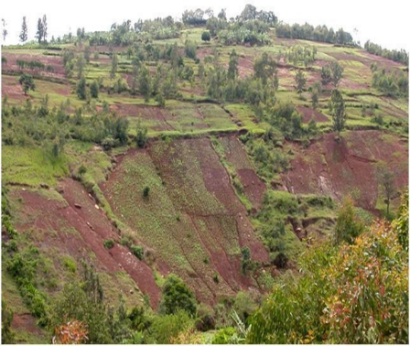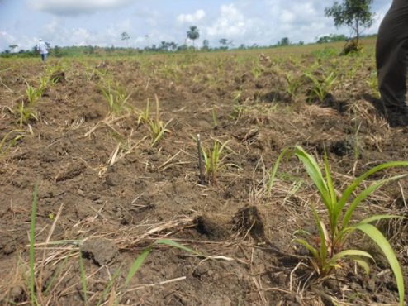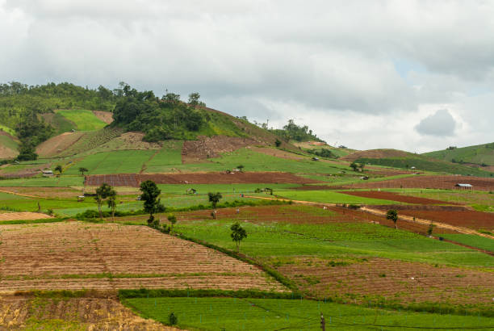
Destruction of natural resources and soil degradation have impoverished the land, resulting in poor harvests and poverty in peasant farming households, with less than one meal per day per household (OCHA report January 2021), very acute malnutrition with very high rates in the provinces as follows (South Kivu 34% (Kabare, Walungu and Uvira), North Kivu 41% (Masisi, Lubero, Walikale), Maniema 40% (Kabambare and Kibombo), Tanganyika 48%, Ituri 52.5% (Djugu and Mahagi)), these data come from a few territories included as part of the sampling.
Faced with this alarming situation, PELUM RDC and its member organizations, in their field of intervention Sustainable, participatory land and natural resource management, and its program of mobilization for agro-ecological transition, have opted to raise awareness and provide training in new agricultural techniques, in order to introduce and experiment with soil-regenerating agriculture to increase the productivity of farmers and improve household food security.
Projects have been developed to launch a regenerative agriculture (RA) program at the heart of its technological intervention as part of its efforts to promote a resilient and sustainable food system in the two provinces in the Democratic Republic of Congo for its first strategic plan 2022-2024. As a system of agricultural practices and principles, AR supports biodiversity, enriches soils, improves watersheds and increases the capacity of soils to sequester carbon (HCWH, 2020). Effective implementation of RA should contribute to increased food, nutritional and monetary security for family farmers in the DRC.
In its quest for RA, member organizations are mobilizing Congolese smallholder farmers and herders to adopt two practices: conservation agriculture (CA) and integrated soil fertility management (ISFM).
Capacitation of peasant farmers in new soil regeneration techniques.
Through 4 member organizations (CEPED, ACPDI, ASOPD and AJDI), PELUM RDC has trained 51,815 small-scale farmers in 291 CEPs in the provinces of North and South Kivu in agricultural techniques for land regeneration and environmental protection to combat climate change through agro-ecological agriculture. These training courses were based on the 6 main principles of AR as set out in the table below:

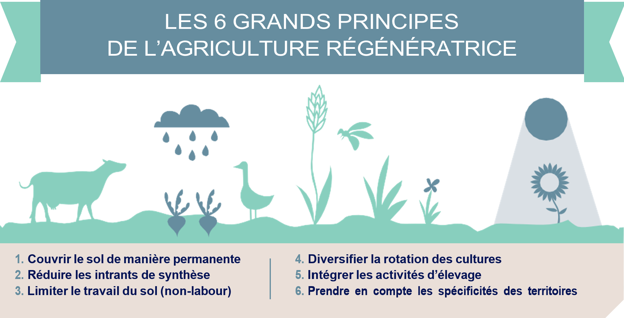
Below are photos of some of the highlights of the demonstration courses
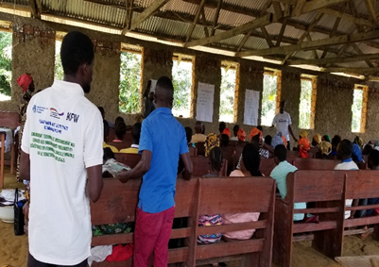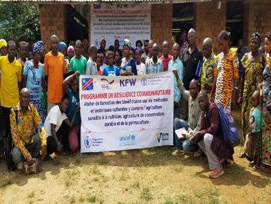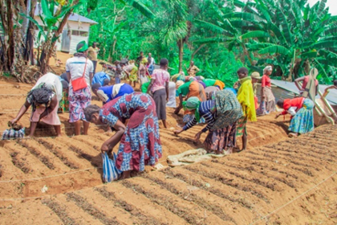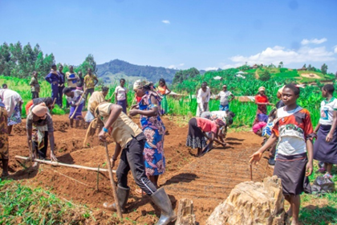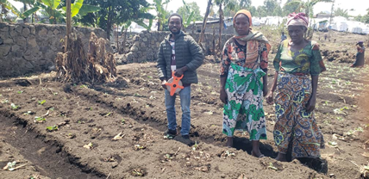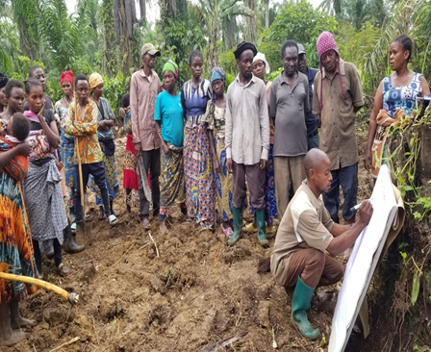
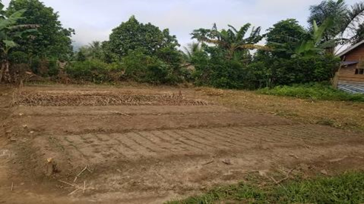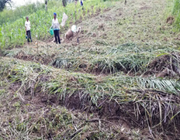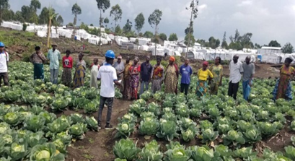
CA practices stimulate soil microbial activity, increase soil fertility, improve soil physical structure and water-holding capacity, and reduce soil erosion. CA is based on the interconnected principles of minimal mechanical soil disturbance, permanent topsoil cover with dead or living vegetation, and crop diversification through rotation or intercropping. Furthermore, CA is considered a climate mitigation strategy that supports the practice of ecological restoration by removing.
carbon dioxide from the atmosphere and storing it in the soil as organic carbon
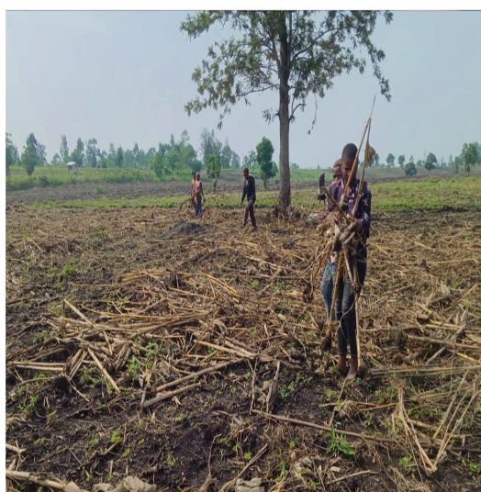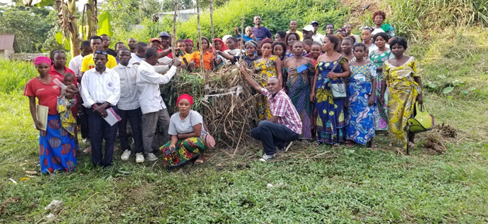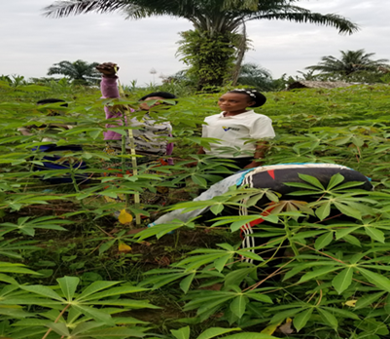
CEPED Ground cover photo CEDERU Compost demonstration AJDI Growth monitoring photo
ISFM is defined as a set of soil fertility management practices that necessarily involves the use of fertilizers, organic inputs, soil amendment techniques, and germplasm in combination with knowledge to adapt these practices to local conditions. ISFM is underpinned by a few key principles, including, but not limited to, optimizing the use of organic sources available on-farm; exploiting the synergy of the combined use of organic and mineral substances and water; and utilizing economically viable natural resources available on-farm.
By adopting ISFM practices, smallholder farmers are able to use organic fertilizers and pesticides more efficiently and maintain yields per unit area at the same level as conventional agriculture. Furthermore, ISFM practices enable resilient agricultural management, reducing both the impact of drought and the need to expand arable land.
As part of our technology intervention strategy, PELUM DRC is committed to several key elements of RA, such as adaptive production technologies that aim to help smallholder farmers cope with the effects of climate change. These practices include the use of drought-tolerant varieties and efficient water management, combined with organic fertilizers, minimum tillage, and herbicides, depending on the agroecosystem and socioeconomic conditions of the target area. However, since producers are unlikely to implement complicated practices, simpler versions have been tried and have given very satisfactory results and will be promoted in the field. 320 200 smallholder farmers was mobilized for climate change and its effects, more than 62,765 smallholder farmers was trained in sols regerative technics, 45 agricultural instructors trained and extension workers have been trained in 256 FFSs, and the implementation of these techniques in their own fields has yielded positive results. A hectare of cassava yielded 3,360 kg, a hectare of beans yielded 2,500 kg, 4,6 tonns by ha of Soute patatos, and the results for market garden produce have been spectacular (see photos above).The procution was increased to 17,5%.
To enable PELUM DRC and its member organizations to expand these experiments, whose results have been very encouraging in reducing food insecurity, financial, material, and human resources are needed to support the continuation of these programs in the DRC. Practices and Achievements
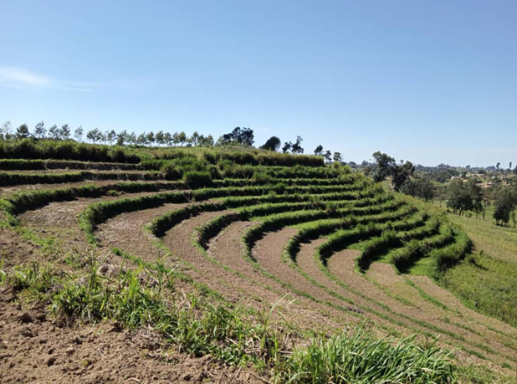
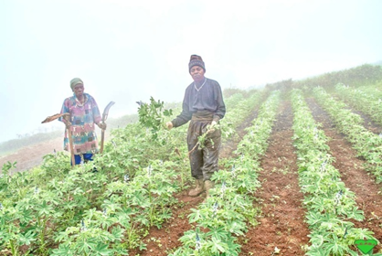
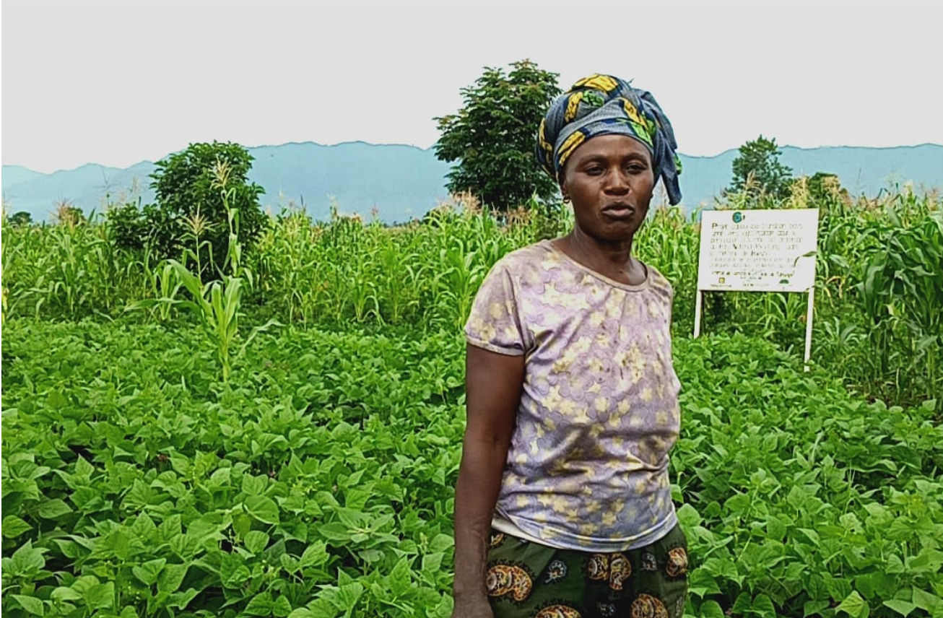
CEPED: Demonstration CEP ACPDI: Sowing techniques ASOPD GL: Terraces radical land
Popularization of semi-row beans r protection
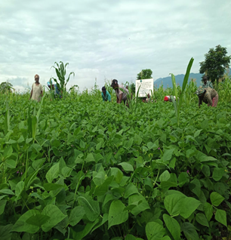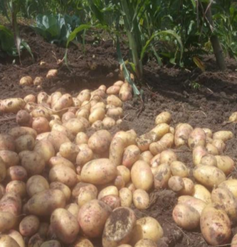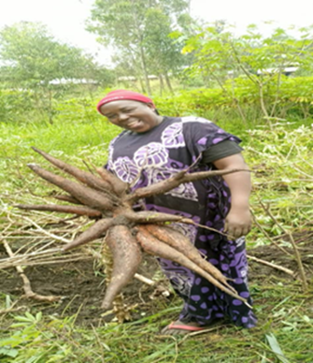
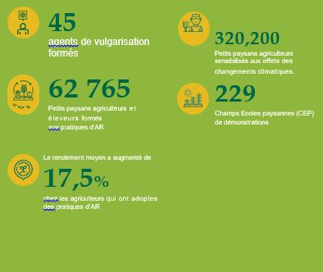
CEPED: Photo: CEP Bean fields ASOPD GL Potato Harvest AJDI :Cassava Haverst photo 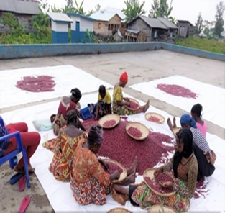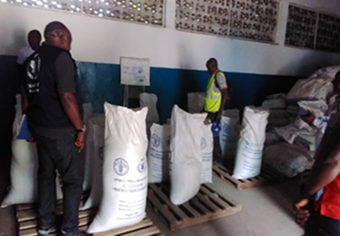
ASOP Congo: Beans post haverst CEDERU: Post haverst and Beans parking
By promoting the GIFS applicator as part of the AR program, PELUM RDC is teaching small-scale farmers new techniques for soil regeneration and natural resource conservation, as well as ways to combat soil degradation and cope with fluctuating fertilizer prices by using organic fertilizers they learn to make from leaves. These innovative tools encourage the rapid adoption of deep application of AEOB fertilizer, which increases efficiency while reducing the environmental impact of excessive runoff. The mechanized applicator also eliminates the difficulties associated with manual fertilizer application. In order to extend the benefits of these techniques and tools, which are showing positive results in eight territories (Beni, Lubero, Goma, Masisi, Rutshuru) in the province of North Kivu and Kabare, Kalehe and Walungu in the province of South Kivu, considered as samples for the RA in 2023-2024. PELUM RDC is seeking financial support to promote this sustainable agriculture approach, which would enable the DRC's eastern provinces to once again achieve the status they enjoyed nearly two decades ago, that of the granary of the DRC and the Great Lakes sub-region.
It also plans to train local manufacturers of organic fertilizers and pesticides by 2030, developing conservation methods to increase the quantities produced and improve access to these products to boost productivity and incomes for farming households, and improve socio-economic conditions.
PELUM RDC and their member organizations take advantage of this publication to express their gratitude to the International Organizations that have financed the projects in which we have tested this approach of Soil Regenerative Agriculture, specifically. PELUM RDC takes this opportunity to express its thanks to all the INGOs and more particularly to the following INGOs: (I) International Union for Conservation of Nature of the Netherlands (IUNC) for the Project Appui a la transtion paysanne vers l'agro ecologie pour la participation citoyenne a la protection de PNKB that OM. executes in the territory of Rutshuru near the Sarambwe forest in the Collectivité de Bwisha, (II) STICHTING PHARUS in synergy with 4U2 DEVELOP PAYS BAS for the Project executed by ACPDI in the territories of Beni, Lubero and Masisi, (III) Louvain Coopération for funding the Rendre l'Agro écologie, l'entrepreunariatet l'insertion socioprofessionnelle inclusive en RDC project implemented by ASOP Congo in the territories of Kabare, Kalehe and Walungu, (IV) FAO for funding the project to promote peace and peaceful cohabitation in the Great Lakes, implemented by ASOPD GL in the Masisi, Rutshuru, Uvira and Kalehe territories. (V) HKIES & FAO for having financed the Projet d'appui aux renforcement des capacités des paysans agriculteurs, executed by CEDERU in the territories of Rutshuru,Masisi and in Ituri a Bunia. (iv), FAO &|PAM for the P4P Project /Community resilience in the territory implemented in the territories of Kalehe and Uvira

